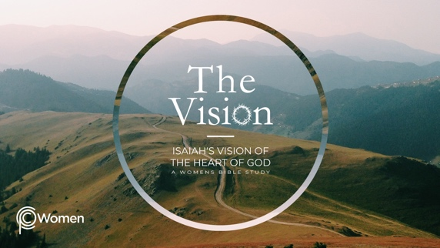
________________________________________________________________________________

LESSON 1

ISAIAH 1-4

1. What did you learn from the overview that has readied you to study the writings of Isaiah? What piques your interest or makes you hesitant?

2. Pray for understanding as you read through the first four chapters of Isaiah. According to Isaiah 1:1, Isaiah was a prophet to Judah during the reigns of four kings of Judah: Uzziah, Jotham, Ahaz, and Hezekiah from 792–686 B.C. As initial background, skim through 2 Chronicles 26:1-20 and note some of the high and low points of Uzziah’s reign.

3. a) In Isaiah 1:2-9, we are in the courtroom of heaven. What are the charges that God issues against Judah and Jerusalem and how did He view the nation? Note: the reference to the Holy One of Israel in these verses includes the nation of Judah.

b) From V9 and Romans 9:22-29 (which quotes Isaiah), how did God treat Judah differently than Sodom and Gomorrah, which were completely destroyed? Why do you think this is important? See Genesis 12:1-3 for insight.

4. Read Isaiah 1:10-20.

- Discuss the focus of God’s displeasure in V10-15 and why the sacrificial offerings were considered meaningless. Examine your own life and consider whether you have burdened the Lord with such things.

- Summarize God’s recommended response to Judah’s wrongdoing in V16-20. How are sin and forgiveness pictured in these verses and where is the compassion of God seen? Refer also to Psalm 103:8-14.

5. In Isaiah 1:21-31, what words capture Israel’s degeneration and what role did it’s rulers play?

6. Contrast God’s view of an ideal future Jerusalem (2:1-5) with the Jerusalem He sees (2:6-22). What of Israel’s future do you long to experience (V1-5) and which of Isaiah’s descriptions of Jerusalem could be said of you, your city, or your culture (V6-22)?

7. Review Isaiah 3:1-4:1. How are the people of Judah, especially the women, characterized by the Lord, and in what ways does the Lord express His divine judgment against them?

8. a) Where and when do you find hope in 4:2-6? What images signify God’s presence at Mount Zion (also the “mountain of the Lord” referred to in 2:3)?

b) From the following verses, what more do you learn about the Branch of the Lord?

- Isaiah 11:1-3

- Jeremiah 23:5-6

- Zechariah 6:12-13

9. Reflecting on who God is: LORD Almighty (Jehovah Saba)

Isaiah first refers to the LORD Almighty in Isaiah 1:9 and 24. He is the One who is all powerful, sovereign over all, and in control of all history. “O LORD Almighty, blessed is the one who trusts in you.” Psalm 84:12. Call upon the LORD Almighty and pray for the will and courage to learn to do right, seek justice and defend the oppressed, or to spur others on to do likewise.

NAME PRAYER REQUEST

