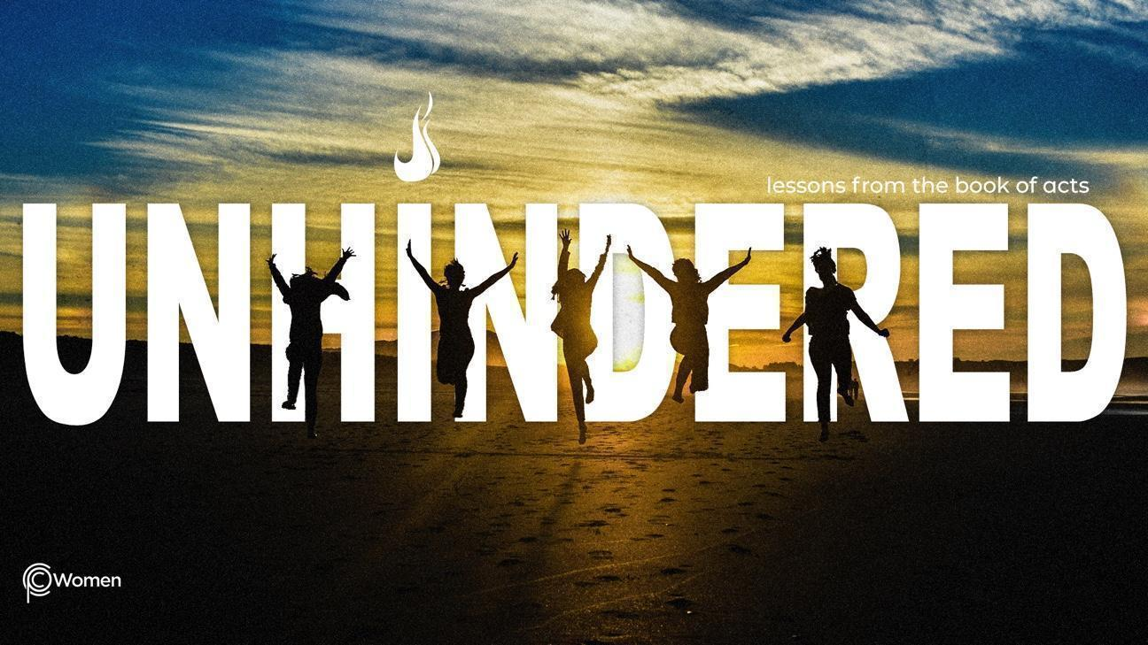
____________________________________________________________________________

LESSON 13

ACTS 15:1 - 16:5

1. Reflect on last week’s lesson and teaching on Acts 13:1 – 14:28. What did you learn – for the first time or again – and how did that strengthen you?

2. Pray and ask for wisdom before reading Acts 15:1-16:5, where the church experienced internal conflict and disagreements. Review the steps taken to resolve the conflict and note how the church differs in approach to conflict from the way the world approaches it.

3. a) What dispute was laid out in Acts 15:1-5? What gave rise to it, and why do you think it was a crucial issue at that time?

b) Identify any similar issues you see as potentially dividing the church today.

4. What group considered the dispute (V6-12) and who stood up to address the group? In your own words, write the essential truths that were expressed.

5. In V13-21, we hear from James, the brother of Jesus, a leader in the church in Jerusalem.

a) What is James’ judgment and how do the verses he quotes from Amos support his position?

b) What are the four areas from which James recommended that Gentile believers abstain, and why do you think he proposed these guidelines following conversion? See Romans 14:13, 19-22 for more insight.

6. Why is the “grace alone” message so important to the gospel? When have you seen something extra added to the gospel message of salvation by grace through faith alone, which burdens new or not-yet believers? See Ephesians 2:8-9 also.

7. What next steps did the council take and how was the church impacted according to Acts 15:22-35?

8. In V36-41, what was the issue between Paul and Barnabas (refer back to Acts 13:13), what were their respective viewpoints, and how was the issue settled? Share your thoughts on the right actions to take in a clash with a fellow believer, including personal experiences.

9. Paul met Timothy in Lystra in Acts 16:1-5. From what you learn about Timothy, and Paul’s plan for him, how do you reconcile the actions taken with Timothy in light of our whole passage today?

10. REFLECT ON THE WORDS OF JESUS

Jesus said “Come to me, all you who are weary and burdened and I will give you rest. Take my yoke upon you… For my yoke is easy and my burden is light.” Matthew 11:28-30. List all the things that are burdening you – your concerns, your conflicts, your disagreements – and then one by one lay them upon Jesus in order to experience His rest.

NAME PRAYER REQUEST

