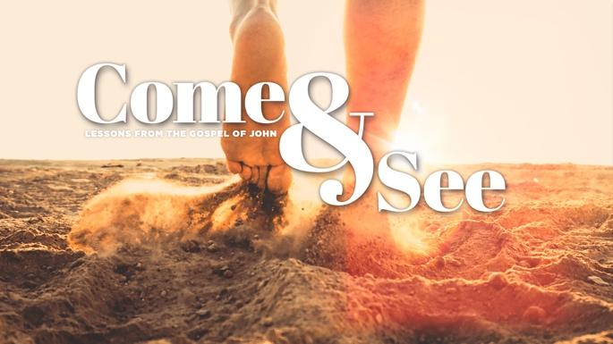

LESSON 8 BREAD OF LIFE

JOHN 6:25-71

1. Last week’s passage in John 5 and 6 recounted several stunning miracles that Jesus, the Sent One, performed. How has your faith been enlarged by marveling at Jesus’ incredible works and words?

2. Read through John 6:25-71. What are some of the repeated phrases and themes you observe and what stirs in you as you take them in?

3. In V25-27, Jesus starts off the day by rebuking the admiring crowds for focusing on material blessings (food) versus the eternal life that He offers. What distracts you from making eternally important things the highest priority in your life?

4. In V28-29, the crowds ask Jesus what work God requires of them and Jesus responds succinctly: to believe in the One He has sent. What do you learn from these additional verses about the importance of belief versus works in a life of authentic faith?

- Ephesians 2:8-9

- James 2:14-17

5. The crowds' questions to Jesus in V28 and V30-31 stemmed from their Jewish heritage. How has your faith journey been influenced by your faith heritage (or lack of faith heritage)?

6. Read V32-40 where Jesus’ proclaims “I AM the Bread of Life“ (V35). List what you learn about Jesus’ purpose, and the benefits of receiving Him as “the true Bread from heaven” (V32)?

7. Though God created humans to have free will, Jesus reveals that God the Father plays a fundamental role in the decision to believe in Jesus. What do the following verses from John 6 teach you about the Father’s role: V37, V39, V44, V65?

8. Jesus repeats the phrase “raise them up at the last day” in V39, V40, V44 and V54. What encourages you from these verses that give more details about the last day?

- 1 Thessalonians 4:16-17

- 1 Corinthians 15:51-55

9. In V42-58, Jesus continues to teach the crowd about the Bread of Life. How does Jesus’ last meal with his disciples described in Matthew 26:26-29 shed more light on what Jesus was teaching the crowds?

10. a) Read V60-71 and list the reactions of the crowd and the Twelve to Jesus’s teaching. What, in the Bible, do you, or those in your life, find are “hard teachings” or find offensive?

b) In V66-69, review how some disciples responded to this “hard teaching” compared to how Peter responds on behalf of the Twelve. What resonates with you?

11. REFLECTING ON HIS NAME: THE BREAD OF LIFE

In the space below, write out a prayer reflecting on both the mystery and the blessing of Jesus as the Bread of Life. “I am the living bread that came down from heaven. Whoever eats this bread will live forever. This bread is my flesh, which I will give for the life of the world.” (John 6:51)

NAME PRAYER REQUEST

